AOW #8 Paired Texts
Directions
- Chunk each short article (and pictures!) into manageable (2 paragraphs max.) pieces. Number them. Don’t forget title/opening!
- Highlight at least three words and define them. (on back)
- Show evidence of a close reading. Mark up the left side of the text chunks with questions and/or comments that demonstrate interacting with the text.
- Identify on the right side of the chunked paragraphs the Purpose, Audience, Techniques, and Tone used by the author. Remember, these can change from one paragraph to another. “Serious” or “formal/informal” is vague if repeated too often. Be specific! Use short phrases if necessary.
- Make sure you HIGHLIGHT words/phrases that indicate the techniques you list!

Julius Caesar Stabbing Site Pinpointed In Rome
The Huffington Post By; Jacqueline Howard
Posted: 10/11/2012 1:16 pm EDT Updated: 10/15/2012 3:52 pm EDT

Archeologists from the Spanish National Research Council believe they have found the precise spot where Julius Caesar was stabbed in Rome--and what they think happened is pretty dramatic.
The scientists said in a written statement that they found a concrete structure, about three meters wide, inside the Pompey's Theater in Rome's historic Torre Argentina square.
The researchers identified the structure as a monument placed in the location of Caesar's murder by order of his adopted son Augustus--a sort of "x marks the spot" discovery.
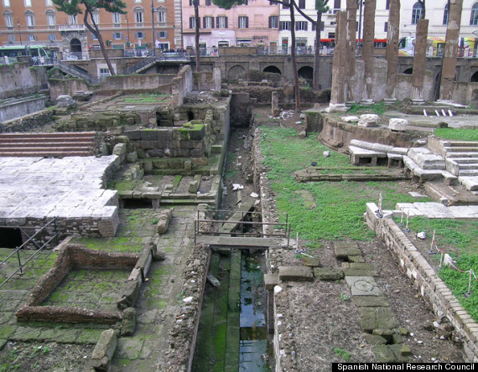
The monumental complex in Rome where researchers suggest Julius Caesar was stabbed

Based on their research and historic texts, the scientists suggest Caesar was stabbed while sitting in a chair as he oversaw a meeting of the Senate at the bottom of the Curia of Pompey. "We always knew that Julius Caesar was assassinated in the Curia of Pompey on March 15, 44 B.C., because the classical texts pass on so, but so far no material evidence of this fact... had been recovered," Dr. Antonio Monterroso, a Spanish council researcher who works at the Institute of History, said in the statement. Monterroso added that the finding is an astonishing part of modern-day life. "Thousands of people today take the bus and tram right next to where, 2,056 years ago, Julius Caesar was stabbed," he said in the statement.
This new research notes where Caesar was stabbed, but not necessarily where he died. "From there the body was taken to the Roman Forum for his veneration and then it was cremated... We don't know if he died in that instant or if he died hours later," Monterroso told the AFP. "All archaeological science is open to dispute, it should be open to dispute, it should be open to argument, it should be open to debate."

Royal Shakespeare Company Updates Julius Caesar With An All-Black Cast At BAM
Posted: 04/22/2013 9:57 am EDT Updated: 06/22/2013 5:12 am EDT

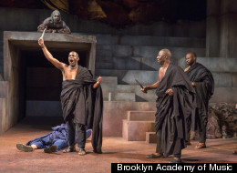
When you step into the Brooklyn Academy of Music's Harvey Theater for the Royal Shakespeare Company's unique production of Julius Caesar, you encounter a pulsing crowd dancing to the beat of African drums.
As I took my seat for Julius Caesar on Thursday night, I passed African revelers cheering Caesar's name, a surprising sight for a tragedy cast in ancient Rome. The gamble worked. Director Gregory Doran's revamped Shakespeare tragedy, including an all-black cast and a modern African setting, is irresistible.
Instead of coming off as a gimmick, Doran's take on of "Julius Caesar" actually makes the play more relevant for today's audience. The unstable political climate of ancient Rome could just as easily be found in, say, Libya today. In fact, in his New York Times review, Ben Brantley likens Jeffery Kissoon's Caesar to the former Libyan despot Muammar el-Qaddafi and Congolese leader Mobutu Sese Seko. Even the grand statue that presides over the stage "inevitably recalls that of Saddam Hussein."
Much credit goes to the actors who make this world believable, although Brutus, played by Paterson Joseph, steals the show. The actor's patient delivery allows us to linger on his sorrow and appreciate his humor, gaining our sympathy for Brutus's moral dilemma; in the end, we really feel for the killer.
The play is updated with visually captivating contemporary dress that ranges from gold watches and dashikis for the senators to a plain undershirt for the handsome Mark Anthony. "Once you get rid of the togas and the sandals, you see what Shakespeare was doing," Doran told Interview Magazine. "He was writing something really, really acute about politics."
By breaking the mold of the stoic Roman setting, the director infuses new life into the play. It cannot be easy to get a modern audience laughing along to Shakespearian puns, but this one even leaped up in a standing ovation at the end of the performance.
