A.O.W. #7 Due Monday
Directions: Since all you have to do is “talk to the text”, I expect to see many annotations.

- Show evidence of a close reading. Mark up the left and right side of the text chunks with questions and/or comments that demonstrate interacting with the text.

Harper Lee's New Book Jacket Revealed!

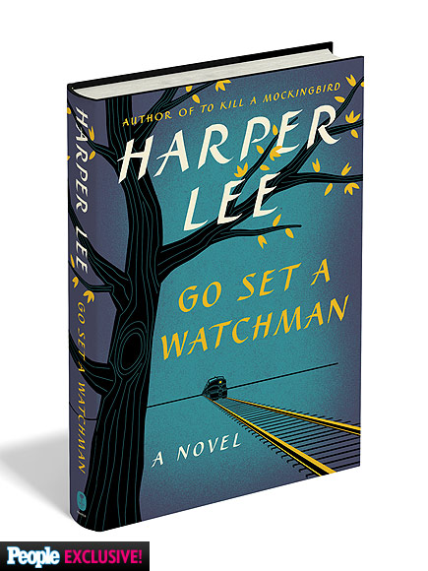
796 SHARES

Join the discussion!
44 Comments subscribe now
steinbeckian • 2 days ago
No one here knows the circumstances of this novel's publication, and the speculation is ridiculous. What it is going to come down to is whether the book is any good or not, something we also don't yet know. If it is, it will endure alongside the first book. If not, it'll be a footnote. I'm looking forward to making my own assessment, and if it gives an 88-year-old living legend a little more money, so be it.
Mrs S • 2 days ago
I'll start with what this article is all about.... I like the simple design of the jacket. Not flashy, but still looks nice. As for Miss Lee.... At 88 years old, let's see what any of us care about our hair. I'd be happy to still have hair, therefore not care about how it was cut. It's between 3 and 4 months before this book is released. l'll bet Miss Lee is rubbing her hands together anticipating all the "cashing in" she's gonna do (cause she has sooooo many years left). First thing, she'll blow that popsicle stand of a retirement home. For her 90th birthday(since her 89th is before the book is released), she'll be sitting on a resort in Hawaii with a Mai Tai in one hand and her dough stack in the other. Now that I've given a sarcasm overload.. Who knows if GSAW will be a success or be as good as TKAM. Miss Lee may be wanting to see what people think one more time before she's gone. Even though she's private, she enjoys the accolades with her first novel. How about for just once, everybody quits being cynical and suspicious about this story?

mnmarcus • 2 days ago
Was it really necessary to put "a novel" on the cover? Looks amateurish.
Guest • 2 days ago
I wasn't a huge fan of the original book. I thought it was more of a long story than an actual book. It was okay, but I didn't think it was the best thing I'd ever read. So no, I'm not really interested in the next chapter of the story. The movie was okay, too, but for some reason I didn't like the kid who played Scout. She seemed whiny or something. I don't know what all the hub-bub is about.
name • 2 days ago
I have a feeling this book is going to be an epic fail. It will never live up to the standards that she created for herself.
Timewilltell name • 2 days ago
Most people remember the movie more fondly than the book. The two versions were slightly different from one another. The charm of TKAMB was that Scout was a child narrating the story. Truman Capote was the one who suggested that HL tell the story from a child's point of view. Capote of course, was the character Dill in TKAMB. The follow up book (which I have my doubts was EVER meant to see publication), features Scout as an adult and was shelved by HL before TKAMB was ever published, on the advice of Capote. And he was right of course. Had TSAW been published (and it really was not publication worthy in its then rough form) instead of TKAMB, it would have faded and been forgotten in all probability. The charm of TKAMB was the innocence of Scout and Jem and how they reacted to those around them and the time in which they grew up. I have a feeling that like many movie sequels, TSAW will not be the hit the pulisher is hoping for. And I have my doubts about HL's state of mind. She is elderly, and somewhat out of it according to many reports. Time will tell the tale.
Cheyenne • 2 days ago
I have a major problem with this book. I'm not sure Harper Lee ever intended for it to be published and there are a lot of concerns that she's being taken advantage of by money-grubbing publishers. Until I'm convinced that she's totally OK with the book coming out, I'm not buying it.
Timewilltell Cheyenne • 2 days ago
I have thought this ever since it was announced that the book was coming out. She is in an assisted living center or a nursing home and previous reports were that she'd sign anything placed in front of her. Why would she allow the publishing of a book that she admitted decades ago was not her best work - or even close? Then, her sister dies and suddenly this work magically appears from the attic of the home they shared (or something like that) and some publisher decides to publish it. I am very skeptical and honestly, while TKAMB told a terrific story (having Truman Capote's help didn't hurt either), I think what most people more fondly remember is the movie version (somewhat - though slightly - different than the book). If you reread the book and then see the movie, you will instantly be able to tell what was left out of the movie version.

