A.O.W. #4 Due: Monday
Directions
- Chunk the article into manageable (2 paragraphs max.) pieces. Number them. Don’t forget title/opening!
- Highlight at least three words and define them. (on back)
- Show evidence of a close reading. Mark up the left side of the text chunks with questions and/or comments that demonstrate interacting with the text.
- Identify on the right side of the chunked paragraphs the Purpose, Audience, Techniques, and Tone used by the author. Remember, these can change from one paragraph to another. “Serious” or “formal/informal” is vague if repeated too often. Be specific!
- Make sure you HIGHLIGHT words/phrases that indicate the techniques you list!

Op-Ed | It’s Time to Address Fashion’s Race Problem
By Jason Campbell 19 January, 2014
The fashion industry is still plagued by a troubling lack of diversity and racial sensitivity and too little is being done about it, says Jason Campbell.
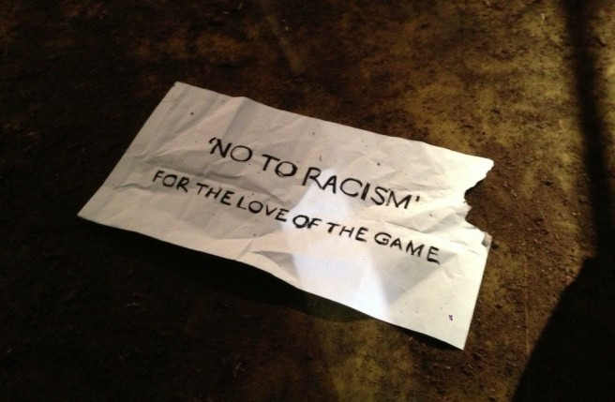At Umit Benan's Jackie Robinson-themed men's collection | Source: BoF
NEW YORK, United States — Back in 2008, when cries were raised about the lack of racial diversity on the runways and in the fashion business at large, Italian Vogue published its timely “all black” issue. Fashion professionals like myself (I was included in the issue) hailed this act of recognition and considered it a watershed moment, a turning of the tide. But fast forward to 2014 and Italian Vogue continues to show its so-called commitment to covering all things fashionable and black with an offensive, misguided and racially insensitive section of its website called “Vogue Black.”
“Vogue Black” was launched back in 2010, but what recently attracted my attention was its coverage from Pitti Uomo in Florence for which the site’s editors thought it appropriate to segregate black street style images in a section of the site’s “Black Blog” called “Vogueista Black.” I had a visceral reaction to this discovery. Do viewers require a different lens to appreciate our sense of style? Is it to say that we’re less or more fashionable? Why separate coverage of us at all?
Separate but equal, the intrinsic message of “Vogue Black,” is a historical concept all too familiar to black people, especially in America. Images of water fountains labelled “white” and “coloured,” and separate seating at diner counters come to mind. One only has to see director Lee Daniels’ recent film The Butler to be reminded of those wrenching representations of being included, but not extended the same benefits and respect. It imparts the impression of otherness; a feeling that you cannot be served here. And you don’t have to have lived in America, or be American, to feel the pangs of this division and empathise with this legacy of injustice and bigotry.
Racism at large is a subject that extends beyond the scope of these pages. But in fashion, we’ve seen some staggering recent examples of racial insensitivity. White girls in black face, slave-themed editorials, skin-lightening and impoverished black kids used as props in designer campaigns are just a few top-of-the-head examples. In October, a firestorm erupted in Milan surrounding the costumes prominent fashion industry players chose to wear to an African Disco-themed Halloween party. The highly offensive outfits — which included slave-chain necklaces, bone piercings through noses and other savage images — smacked of an ill-informed community playing recklessly with racially charged imagery. The backlash was hard and swift, but what left me stunned was a fundamental question: What was going through the minds of these individuals in the first place for them to make such callous choices? What exactly are their impressions of black people such that what could have been a glamorous theme (a generous appraisal) was turned into a stage for the portrayal of blacks as savage caricatures and uncivilized animals?
If much of this is kind of behavior is attributed to ignorance, the industry is showing little interest in expanding its knowledge. At the crux of the matter is the fact that, at fashion companies, senior decision-makers and their teams are largely composed of white people and there is zero initiative to change the status quo. As the lack of racial diversity continues to plague the industry, misguided decisions, such as the one to launch “Vogue Black” and segregate coverage of stylish blacks, are often taken because fashion’s boardrooms and editorial meetings are missing people who could bring alternative perspectives. Race is a sensitive matter, particularly when you’re on the side of a historically marginalised group. And consideration of racial history when deciding how to portray these matters is important.
This type of insensitive behaviour seems in opposition to the work being done by the Diversity Coalition, headed by Bethann Hardison, Naomi Campbell and Iman, which focuses on policing the runways and holding designers who feature all-white casts accountable. Importantly, this initiative is not asking for runways solely for black models. The aim is to have a variety of ethnicities in the same lineup, creating a rainbow presentation that reflects the diversity of beauty that exists on this planet. It’s an initiative that aims for inclusion, but not any cost and not segregated off in colour-specific corridors. True diversity comes when differences are not defined by colour. It’s not to say that we’re not proud of our differences. Variety is most definitely the spice of life, but let’s see it on the same page.
There is hope, of course. Riccardo Tisci is one designer who has been exemplary in his rainbow casting, both on the runway and in his campaigns, during his tenure at Givenchy. The Spring/Summer 2014 Givenchy campaign is a visual feast of variety, featuring the likes of singer Erykah Badu and models Maria Borges and Asia Chow.
And just this weekend, Umit Benan confronted the issue of racism head-on in a Jackie Robinson-themed collection titled “No To Racism, For the Love of the Game.” The cover of this month’s Dazed & Confused featuring the stunning Lupita Nyong’o is another positive example. There’s no racial label attached to it. Like her white counterparts who’ve appeared on the magazine’s covers before, Nyong’o is simply a beautiful woman, a talented actress and a burgeoning style icon. Is that not enough?
Jason Campbell is editor-in-chief of JC Report and the founder of ClosetHQ.

